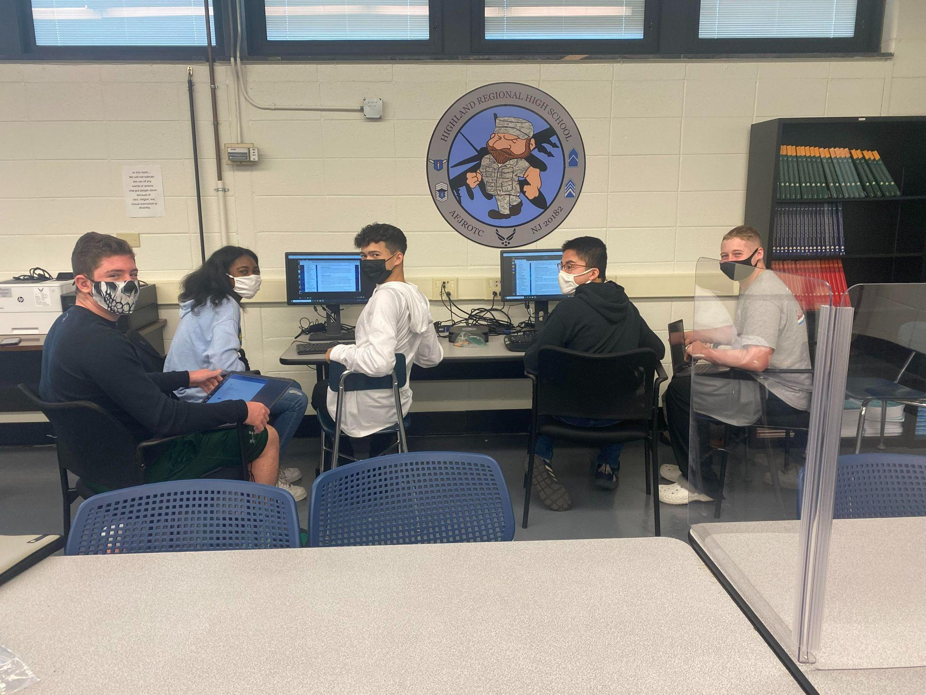

Cadets from Highland High School’s Air Force Junior Reserve Officer Training Corps (AFJROTC) are competing in the Air Force Association’s 14th annual CyberPatriot competition. CyberPatriot is the Air Force Association's National Youth Cyber Education Program, created to inspire K-12 students toward careers in cybersecurity or other science, technology, engineering, and mathematics (STEM) disciplines critical to our nation's future.

At the center of CyberPatriot is the National Youth Cyber Defense Competition, which puts teams of high school and middle school students in the position of newly hired IT professionals tasked with managing the network of a small company. Through a series of online competition rounds, teams are given a set of virtual operating systems and are tasked with finding and fixing cybersecurity vulnerabilities while maintaining critical services. The top teams in the nation earn all-expenses-paid trips to Maryland for the National Finals Competition where they can earn national recognition and scholarship funds.

Highland High School AFJROTC is competing for the first time this school year. Cadets Nicholas Grungo, Jason Savage, Ethan Hicken, and Jamari Robinson have completed training sessions, practice rounds, and one live round under the supervision and direction of team captain, Connor Brennan. The team continues to train in Windows, Ubuntu, and Cisco Systems material in preparation for the second round of competition in November.

If you have any questions on Cyber Patriot or Air Force JROTC please contact Major Simpson [rsimpson@bhprsd.org](mailto:rsimpson@bhprsd.org) or Chief Mahoney [rmahoney@bhprsd.org](mailto:rmahoney@bhprsd.org).